Introduction
FutureGate Healthcare Solutions (FGHS), in collaboration with OSSI, is pleased to submit this proposal for the Supply, Integration, and Maintenance of the OneSource Connect® RMS with AI-Ready Foundation Solution for the Ministry of Health – Kingdom of Saudi Arabia (MOH).
This proposal supports the Ministry of Health’s strategic objective of enabling comprehensive medical device connectivity, real-time clinical data availability, and intelligent healthcare infrastructure across the Riyadh Third Health Cluster. The proposed solution will enable the integration, aggregation, and secure transmission of medical device data from 50 critical care beds distributed across multiple ICU departments in 14 hospitals.
The proposed platform establishes a robust digital healthcare infrastructure that will:
• Seamlessly integrate bedside medical device data with the Hospital Information System (HIS), enabling accurate, real-time clinical information exchange across hospital systems.
• Provide healthcare facilities with a secure, AI-ready, and regulation-compliant connectivity framework, allowing the deployment of advanced clinical applications such as predictive analytics, remote patient monitoring, and intelligent clinical decision support.
• Establish a scalable and interoperable digital ecosystem capable of supporting future innovations in connected healthcare, while improving operational efficiency and enhancing the quality of patient care.
At the core of the proposed solution is the OneSource Connect® Foundation – JAMES Infrastructure-Embedded Medical Device Integration (MDI) System, a vendor-agnostic platform designed to transform medical device connectivity into a built-in hospital infrastructure service. By integrating device-specific connectivity dongles, wall-embedded Power-over-Ethernet (PoE) micro-network architecture, and edge-based processing units, the system provides secure, standardized, and high-fidelity access to clinical device data.
This architecture ensures:
- Interoperability between heterogeneous medical devices
- Secure and governed medical data flows
- Support for advanced analytics and AI-enabled healthcare applications
- Alignment with international healthcare interoperability and cybersecurity standards
- Full compatibility with the Ministry of Health’s digital transformation initiatives
FGHS and OSSI are fully committed to delivering a future-proof, reliable, and high-quality solution, supported by comprehensive implementation services, training, and long-term technical support. Our joint objective is to ensure the successful deployment, operational stability, and sustainable growth of the TeleICU infrastructure across the participating MOH hospitals.

Overview and Deliverables

OneSource Connect® RMS – TeleICU Solution

Business Benefits
The OneSource Connect® RMS TeleICU platform delivers significant clinical, operational, and technological benefits to healthcare providers by enabling secure, real-time integration and remote access to medical device data across distributed hospital environments.
- Remote Clinical Presence
The platform enables both real-time and retrospective remote monitoring of patients across multiple hospitals, allowing clinicians to observe patient conditions continuously and support bedside teams through centralized TeleICU command centers.
- AI-Ready Data Infrastructure
The system collects, normalizes, and synchronizes physiological data from connected medical devices, creating a structured and governed data environment that is ready to support advanced analytics, artificial intelligence applications, and predictive clinical models.
- High-Fidelity Data Synchronization
Waveforms, vital signs, and device parameters are synchronized with millisecond-level precision, ensuring high data fidelity for accurate clinical interpretation, trending analysis, and advanced monitoring applications.
- Positive Patient Identification (PPID)
Integrated Positive Patient Identification (PPID) mechanisms ensure that all collected clinical data is securely and accurately associated with the correct patient record, reducing the risk of documentation errors and improving data integrity.
- Real-Time Clinical Accessibility
The system enables secure access to patient data both within the hospital network and through authorized remote connections, allowing clinicians to monitor patients and review clinical information regardless of location.
- Open Architecture and Standards-Based Integration
The platform is built on open standards and interoperable protocols, enabling seamless integration with medical devices from multiple vendors and compatibility with hospital information systems such as HIS, EMR, and clinical analytics platforms.
- Scalable System Architecture
The solution is designed to support scalable deployments, ranging from individual hospital departments to large multi-hospital healthcare networks, ensuring long-term adaptability as healthcare infrastructure evolves.
- Transparent Integration Framework
The system follows a transparent and standards-based integration model, ensuring that data exchange processes remain auditable, secure, and compliant with healthcare interoperability requirements
- Web-Based User Interface and API Integration
A web-based graphical interface allows clinicians to access monitoring dashboards through standard browsers, while secure APIs enable integration with third-party healthcare systems and analytics platforms.
- Independence from External Web Services
The solution can operate fully within hospital-controlled infrastructure, without reliance on external third-party web services, ensuring reliability, data sovereignty, and compliance with healthcare data governance policies.
- Flexible Deployment Models
The platform supports on-premise, cloud-based, or hybrid deployment models, allowing healthcare organizations to adopt the solution in alignment with their existing infrastructure and cybersecurity policies.

System Features and Advantages
The overall architecture of the TeleICU solution, including the data flow from bedside medical devices to the centralized monitoring platform, is illustrated in Figure 1 – End-to-End TeleICU Architecture.
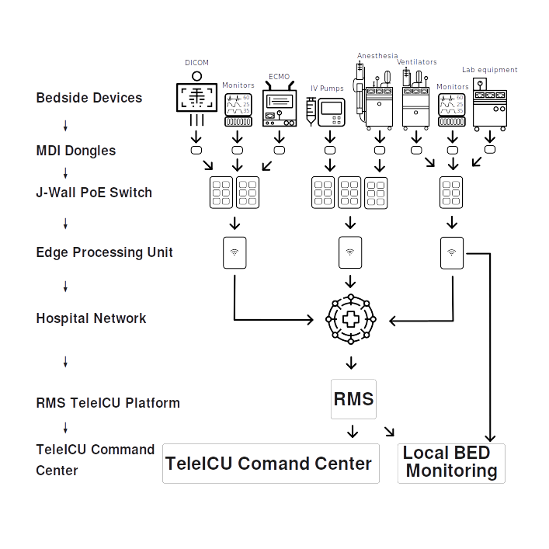
TeleICU Solution Functional Capabilities
# | Specification
1 | Critical Bed Connectivity: ICU beds across participating hospitals are connected to the TeleICU platform through secure hospital network infrastructure, enabling centralized monitoring and data aggregation.
2 | Real-Time Physiological Data Transmission: The system collects and transmits patient physiological data in real time, including vital signs, ventilator parameters, infusion pump data, and other device measurements from supported bedside medical devices.
3 | IP Camera Support for Remote Consultation: Each ICU or NICU bed can optionally integrate one or more IP cameras for remote visualization and teleconsultation. The system supports standard IP camera protocols such as JPEG and MJPEG video streams with configurable resolution and image size.
4 | Synchronized Multi-Device Monitoring: The platform synchronizes real-time medical device data, waveforms, and video streams from multiple sources including patient monitors, ventilators, infusion pumps, and other supported devices.
5 | Multi-Vendor Device Integration: The system supports simultaneous integration of medical devices from multiple manufacturers, including patient monitors, ventilators, and infusion pumps.
6 | Automatic Respiratory Loop Visualization: When interfaced with compatible ventilators, the platform automatically generates clinical respiratory loops such as flow-volume and pressure-volume curves based on the available device data.
7 | Secure Web-Based Access: Authorized users can access patient monitoring dashboards, waveforms, and device data through a secure web-based interface using standard web browsers.
8 | Remote Ventilator Monitoring: Ventilator modes, configuration parameters, and associated patient data can be viewed remotely without requiring direct bedside interaction.
9 | Structured Vital Signs Visualization: The platform provides organized visualization of physiological parameters including systolic, diastolic, and mean blood pressure, heart rate, oxygen saturation, respiratory rate, mean arterial pressure, and body temperature.
10 | Correlation of Device Settings and Patient Physiology: The system enables clinicians to compare ventilator settings with real-time physiological indicators such as heart rate, blood pressure, oxygen saturation, respiratory rate, and end-tidal CO₂.
11 | Flexible Charting and Trend Visualization: The system supports multiple charting modes for displaying trends, waveforms, and time-based physiological data.
12 | Clinical Data Archiving and Playback: The platform records and stores synchronized patient monitoring data for a minimum of six months, allowing clinicians to review historical events and replay recorded monitoring sessions.
13 | Multi-Bed Monitoring View: The TeleICU command center can simultaneously display data from multiple ICU beds, enabling centralized monitoring of patients across different hospital locations.
14 | Single-Patient Detailed View: Clinicians can access a dedicated view for individual patients, including detailed waveforms, trend charts, and synchronized physiological signals.
15 | Medical Device Alarm Monitoring: The system captures and displays alarms and warnings generated by connected medical devices without modifying the original alarm descriptions.
16 | Real-Time Clinical Alerts: Configurable alerts can notify clinical staff when predefined physiological thresholds or device events occur.
17 | Integration with Hospital Information Systems: The platform supports integration with hospital systems including HIS and EMR using healthcare interoperability standards such as HL7 and FHIR.
18 | Automatic Device Discovery and Configuration: Supported medical devices are automatically detected and configured through device-specific connectivity modules and driver libraries.
19 | Secure Data Transmission: Communication between bedside devices, hospital servers, and remote users is secured using encrypted protocols such as TLS and VPN tunnels.
20 | Zero-Trust Security Model: The system supports role-based access control, multi-factor authentication, and secure identity management to protect access to clinical data.
21 | Medical Device Network Isolation: The architecture ensures secure isolation between medical devices and hospital IT networks to meet cybersecurity and patient safety requirements.
22 | High Availability and System Redundancy: Built-in failover and redundancy mechanisms ensure system availability of up to 99.99% uptime.
23 | High-Frequency Data Processing: The system supports millisecond-level data acquisition and processing (up to 1000 Hz) for high-fidelity physiological monitoring.
24 | TeleICU Command Center Visualization: A centralized command center interface allows clinicians to monitor multiple patients simultaneously across multiple screens.
25 | Future-Ready AI Integration: The system architecture supports future integration of artificial intelligence applications and advanced clinical analytics without requiring major infrastructure changes.
26 | Flexible Deployment Models: The TeleICU platform can be deployed in on-premise, cloud, or hybrid environments depending on hospital infrastructure and cybersecurity requirements.

